User Interface Prototype Guide

Prepared by Elementary Engineers:

Olga Sheehan, Sara Hakkoum,

Eric Holm, Ethan Fiero

Instructor: Dr. Jung

Framingham State University

Spring 2016

## Abstract

The “Fraction Worksheet Creator” (FWC) is an off-line worksheet generation tool designed by Elementary Engineers to help elementary school teachers to create a lot of exercises for students to study and practice fractions. The fractions worksheets are randomly created and never repeated so the teachers have an endless supply of quality fractions worksheets to use in the classroom or at home.

The purpose of this document is to give a detailed paper prototyping of the requirements for the “Fraction Worksheet Creator” (FWC) software for the user. It will illustrate the prototype drawn in a mockup creation and prototyping tool and demonstrate the features of the software. It will also explain the interface with all its functionalities in the requirements documentation.

This document is primarily intended to be proposed to a customer and the board of directors for their approval and a reference for developing the first version of the system for the development team.

Table of Contents

Overview 3

Admin Software Registration 4

Login 4

User forgot the password 5

Administrator password reset 5

Admin Home 6

Admin – Reset passwords 6

Admin – Teacher Profile 7

Teacher registration 7

Teacher – Forced password reset 8

Teacher Home 8

Teacher – Worksheet History 9

Teacher – Classes 9

Teacher – Adding a New Class 10

Teacher – Edit Class 10

Student registration 11

Teacher – Class roster 11

Teacher – Student profile 12

Teacher – Student worksheet history 12

Teacher – Student password reset 13

Student – Home 13

All users – Tutorials 14

Single tutorial 14

Student worksheet history 15

Help 15

My Account 16

Graphical Mockup 16

## Overview

Basics

The Fraction Worksheet Creator should be installed by the person you will designate as your administrator. They will have the ability to add/remove teachers from the system and can assist in resetting teacher passwords.

Users will first be presented with a login screen.

From this screen they can also reset their password using the FORGOT PASSWORD button.

All Users

All users will have standard buttons available on the top menu bar.

* HELP – For context sensitive help using a pop-up window
* ACCOUNT – For account information and options based on user level (ADMIN, TEACHER, STUDENT)
* LOGOUT – To exit the system

All users will have a secondary menu bar located below the main logo.

These buttons available will differ based on user level (ADMIN, TEACHER, STUDENT)

Admins

Admins have three available screens.

* HOME – Where they can edit teacher profiles
* PASSWORD RESET – Where they can reset teacher passwords
* ADD TEACHER – Where new teachers can be added

Teachers

Teachers will have five available screens

* HOME – Shows all available worksheets for printing
* TUTORIALS – Shows all available tutorial videos
* HISTORY – Show teacher worksheet history
* CLASSES – Shows student rosters for each class, allows editing of student accounts, allows editing of class rosters, allows viewing of student worksheets and answer sheets.
* PASSWORD RESET – Allows teacher to reset student passwords

Students

Students will have three available screens

* HOME – Shows all available worksheets for printing
* TUTORIALS – Shows all available tutorial videos
* HISTORY – Show student worksheet history

## Admin Software Registration

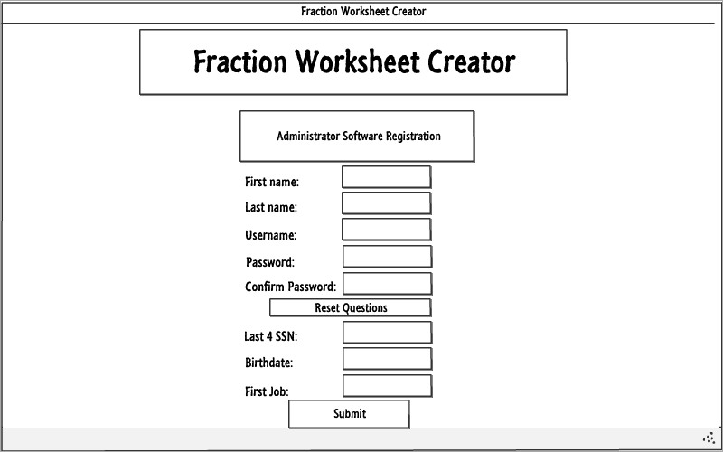

This page is used to register the Administrator as the first user of the software right after installation and asks for security questions to check for in the event that the Administrator forgets the master password and needs to reset it.

## Login

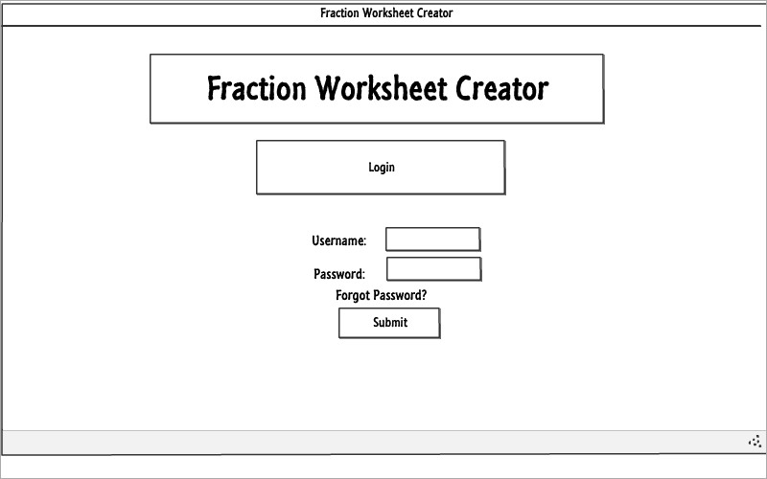

All users use the same login screen to login to the FWC. If a user forgets his/her password, clicking forgot password displays the next page.

## User forgot the password

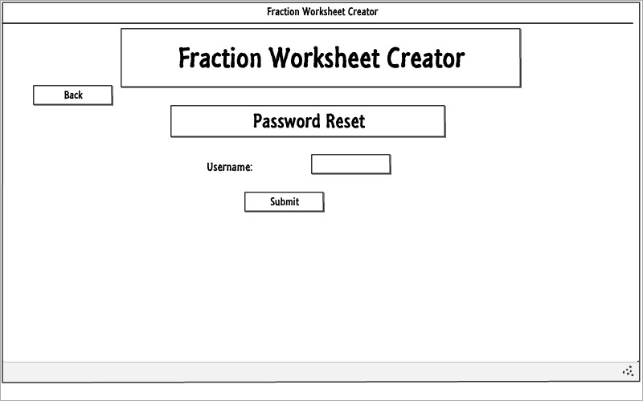

Based on the username, this page determines whether the user is a teacher/student/admin and handles the forgot password request accordingly. Teachers have the request sent to the admin, and students have the request sent to their teacher. Admins that forget their password will be taken to the next page.

## Administrator password reset

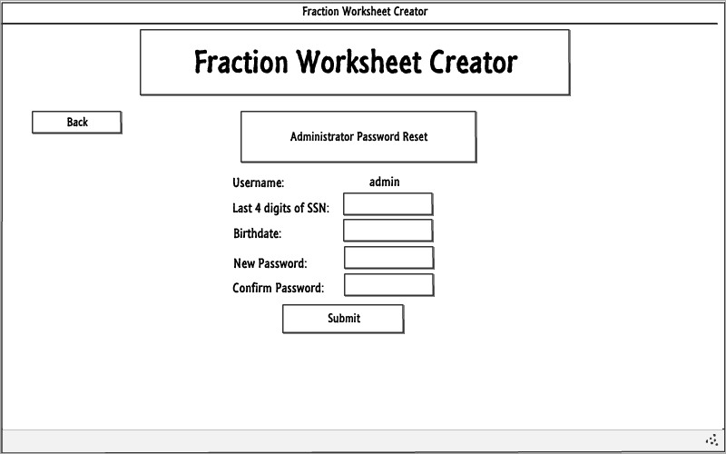

The Administrator answers the security questions that he/she was asked during registration. If the answers are correct, the master password will be reset.

## Admin Home

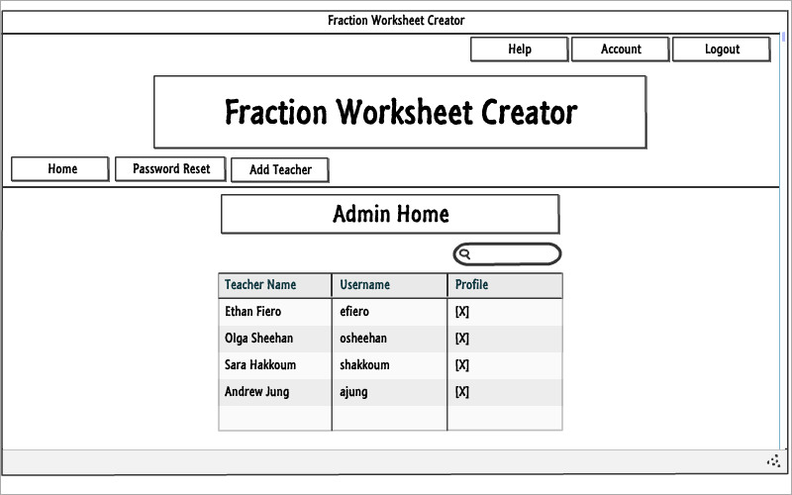

A list of registered teachers is displayed on the Admin homepage. A profile button next to each teacher allows the Admin to view a teacher’s profile to make changes.

## Admin – Reset passwords

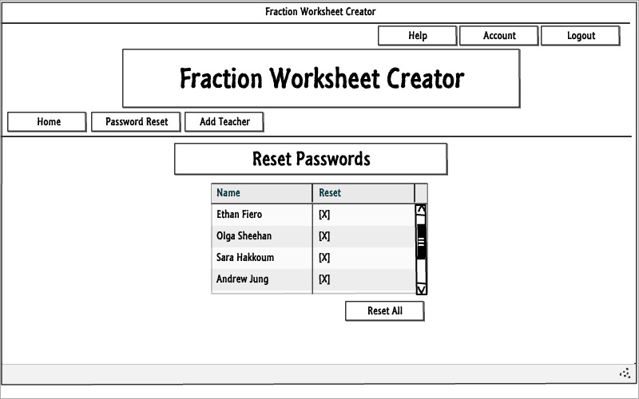

The Password Reset button displays this page, where the Admin sees a list of teachers that have requested a password reset through the forgot password page. The Admin can reset the password of particular teachers or all teachers that requested it at once.

## Admin – Teacher Profile

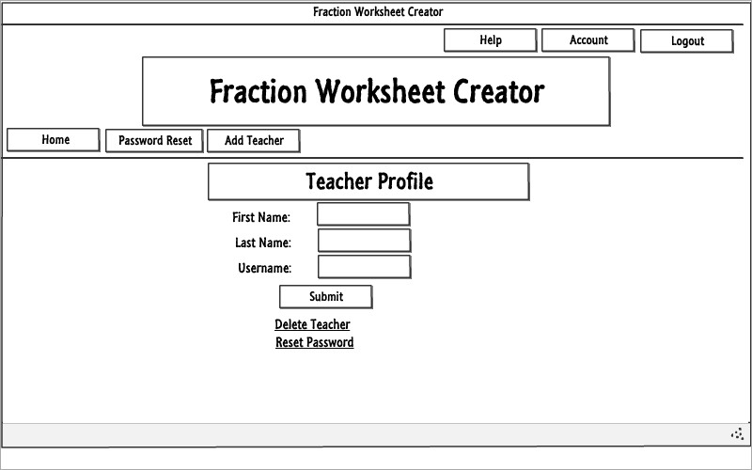

This is a teacher’s profile as viewed by the Admin, where the Admin can reset a teacher’s password on-demand or delete the teacher account, as well as makes changes to the teacher name and username.

## Teacher registration

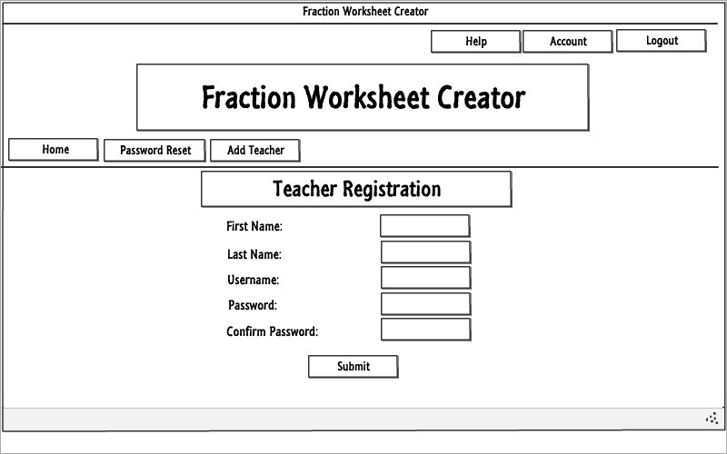

Teachers are registered by the Admin using this page, which is reached by clicking the Add Teacher button in the menu.

## Teacher – Forced password reset

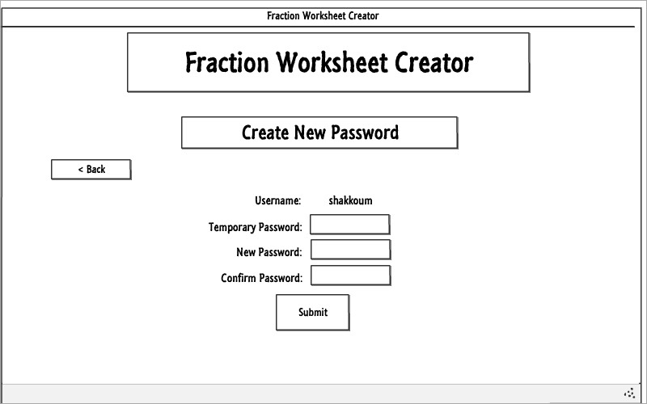

When the Admin resets a teacher’s password, this is the page the teacher sees the next time he/she logs in with the temporary password set by the Admin. The teacher must reset his/her password before logging in.

## Teacher Home

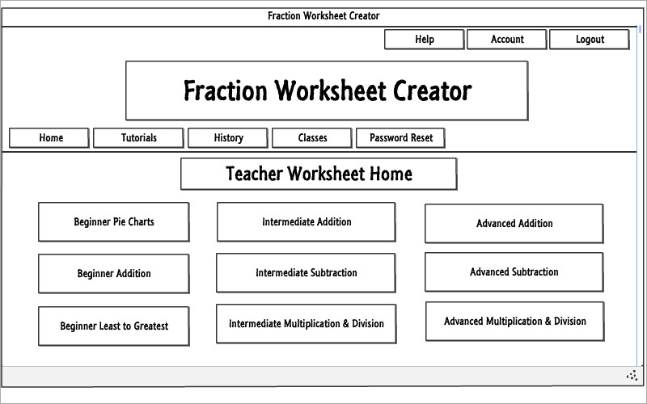

The teacher homepage is where the teacher can generate random fractions worksheets of different difficulties and exercise types.

## Teacher – Worksheet History

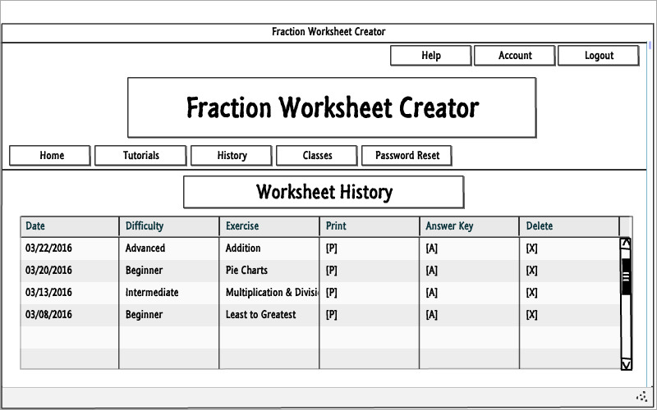

The History button takes the Teacher to this page which displays his/her worksheet history, allowing the Teacher to print old worksheets, view their answer sheets, and delete them from the history.

## Teacher – Classes

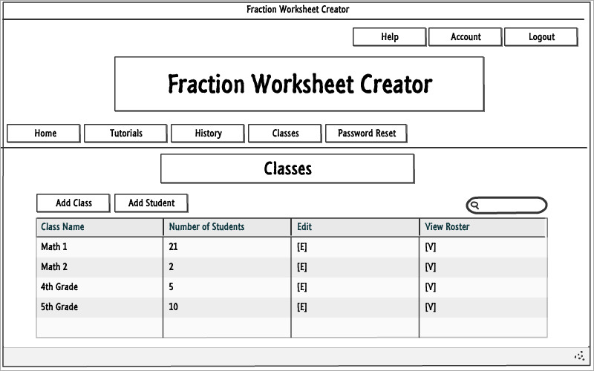

The Classes button displays this page which allows teachers to add a class, add a student to an existing class, search classes, modify classes, and view a class’ roster.

## Teacher – Adding a New Class

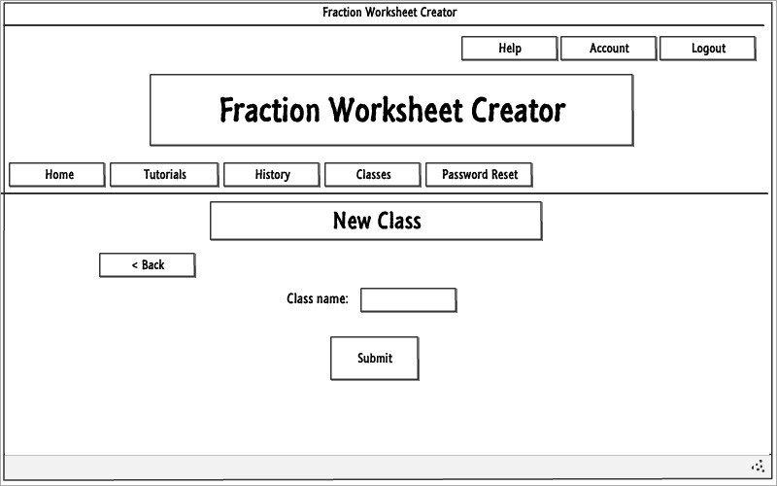

The Add Class button on the previous page takes the Teacher to this page that allows him/her to easily create a new class to add students to.

## Teacher – Edit Class

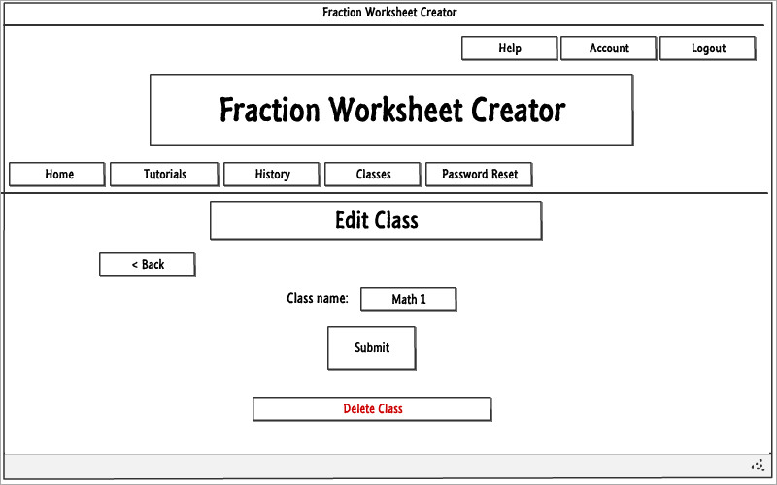

Clicking the Edit button next to a class on the Classes page displays this page which allows teachers to rename a class or delete the class, which also deletes all the students in that class. A warning message will be displayed.

## Student registration

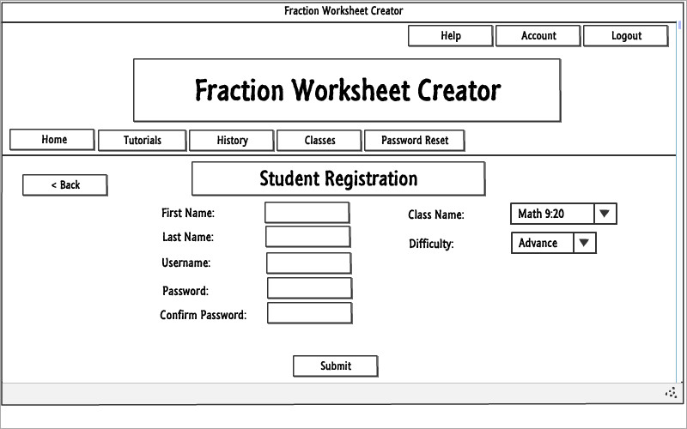

The Add Student button on the Classes page displays this page which allows teachers to create a new student and add him/her to an existing class, setting all the required information.

## Teacher – Class roster

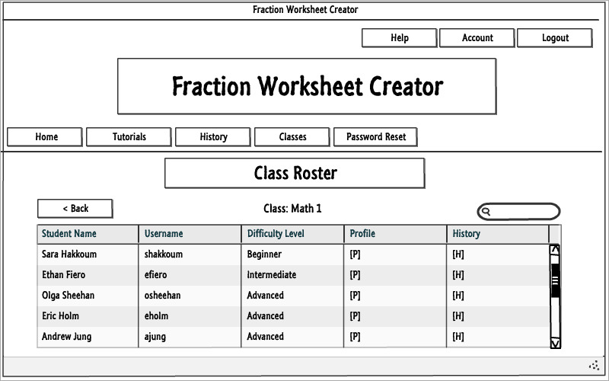

Clicking the View Roster button next to a class on the Classes page displays a roster for that class, a list of students that have been assigned to that class. From here, teachers can search for students and view their profiles and worksheet history.

## Teacher – Student profile

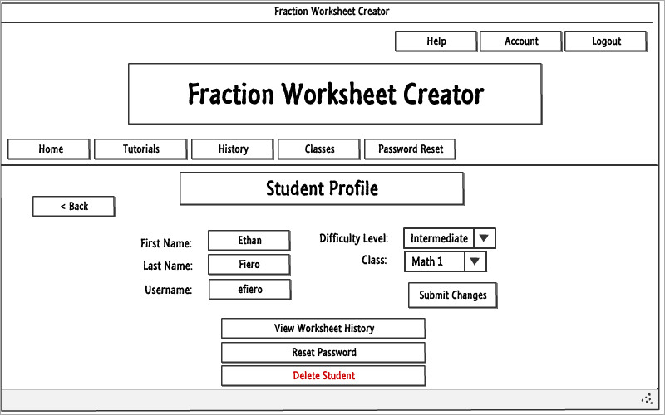

Clicking the Profile button next to a student in a class roster displays this page, where a teacher can edit that student’s information, including changing the difficulty level or class assignment of that student, resetting the student’s password, and deleting the student. Student worksheet history can also be reached from here.

## Teacher – Student worksheet history

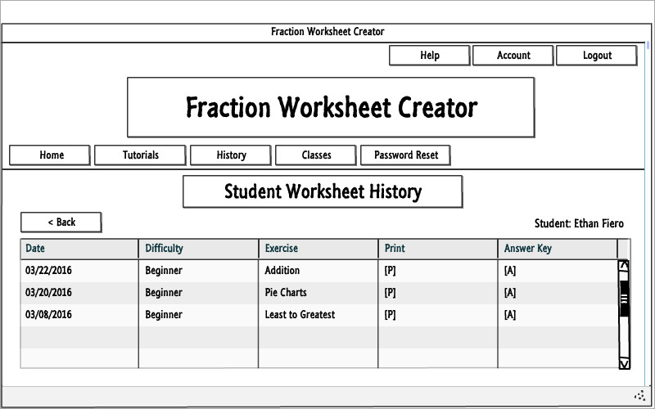

Clicking the History button either next to a student in the Class Roster page or in a Student’s Profile displays the student’s worksheet history. Teachers can print a student’s old worksheet or answer sheet, but cannot delete student worksheets.

## Teacher – Student password reset

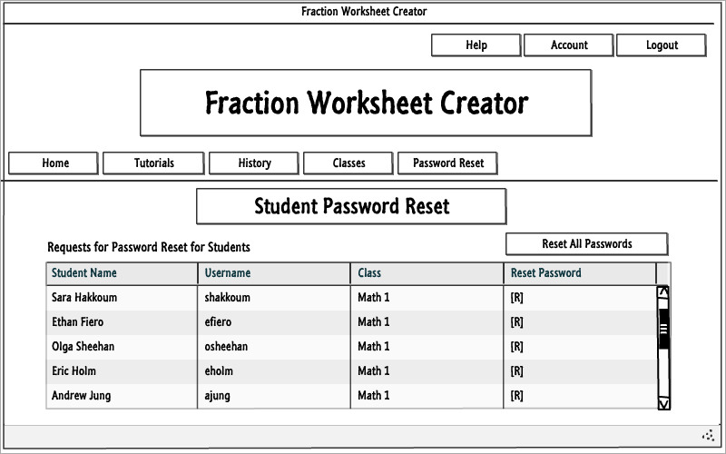

Similar to an Admin, Teachers can reset the passwords of students that have requested it in the Forgot Password page by clicking the Password Reset button in the menu. They can reset the passwords of particular students or all students that requested it at once.

## Student – Home

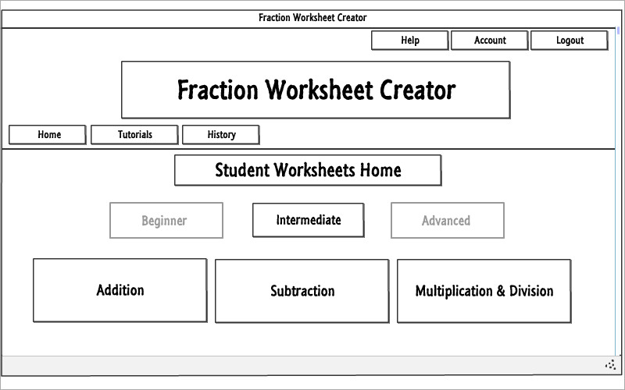

The student homepage allows him/her to generate worksheets of his/her assigned difficulty level.

## All users – Tutorials

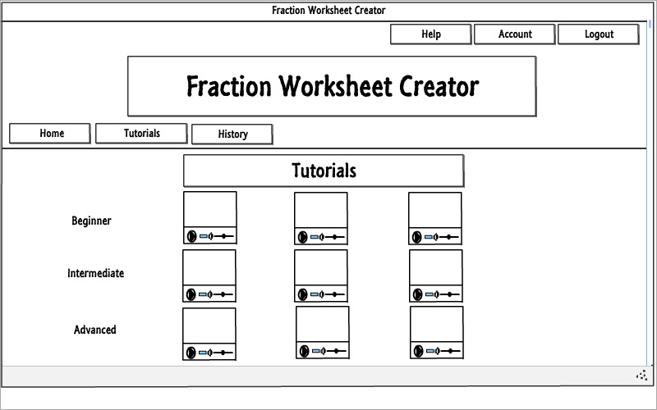

Tutorials can be viewed by teachers and students by clicking on the Tutorials button in the menu. This page displays a tutorial for every worksheet difficulty and exercise type combination.

## Single tutorial

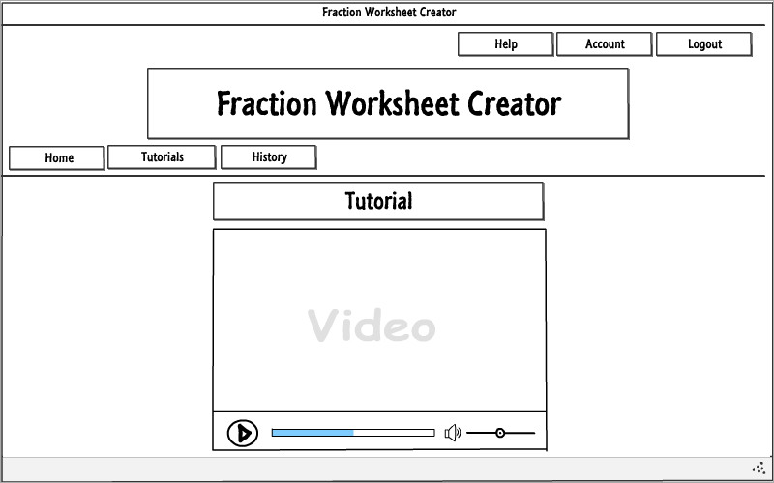

Clicking on a single tutorial thumbnail in the Tutorials page displays another page containing the video that can be played from inside the FWC software. To go back to the list of tutorials, teachers/students can click the Tutorials button in the menu.

## Student worksheet history

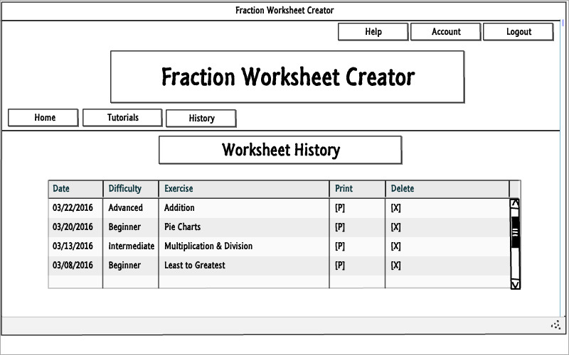

Students may view their own worksheet history by clicking the History button in their menu. They can print and delete worksheets they previously generated, but cannot view answer sheets.

## Help

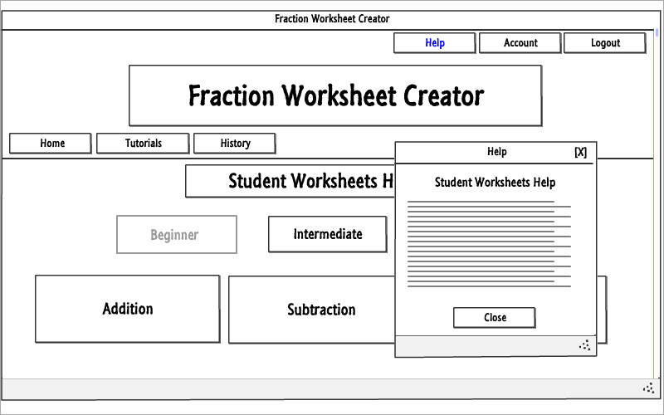

The help utility can be accessed from any page, and by all users, after logging in to get context-sensitive help as a pop-up depending on the page the user is currently on when the Help button in the top menu is clicked.

## My Account

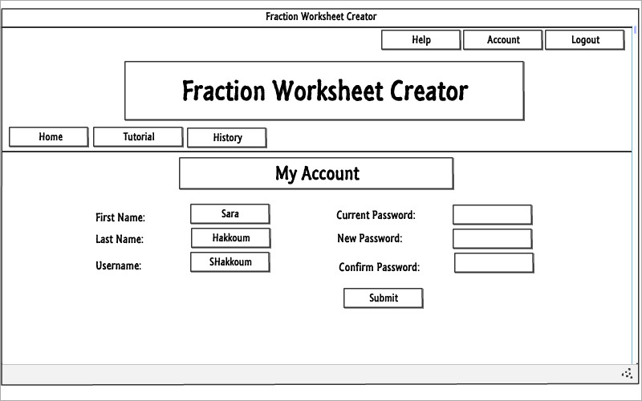

The My Account page can be accessed by all users by clicking the Account button in the top menu. It displays the user’s information and allows him/her to reset his/her password at will.

## Graphical Mockup

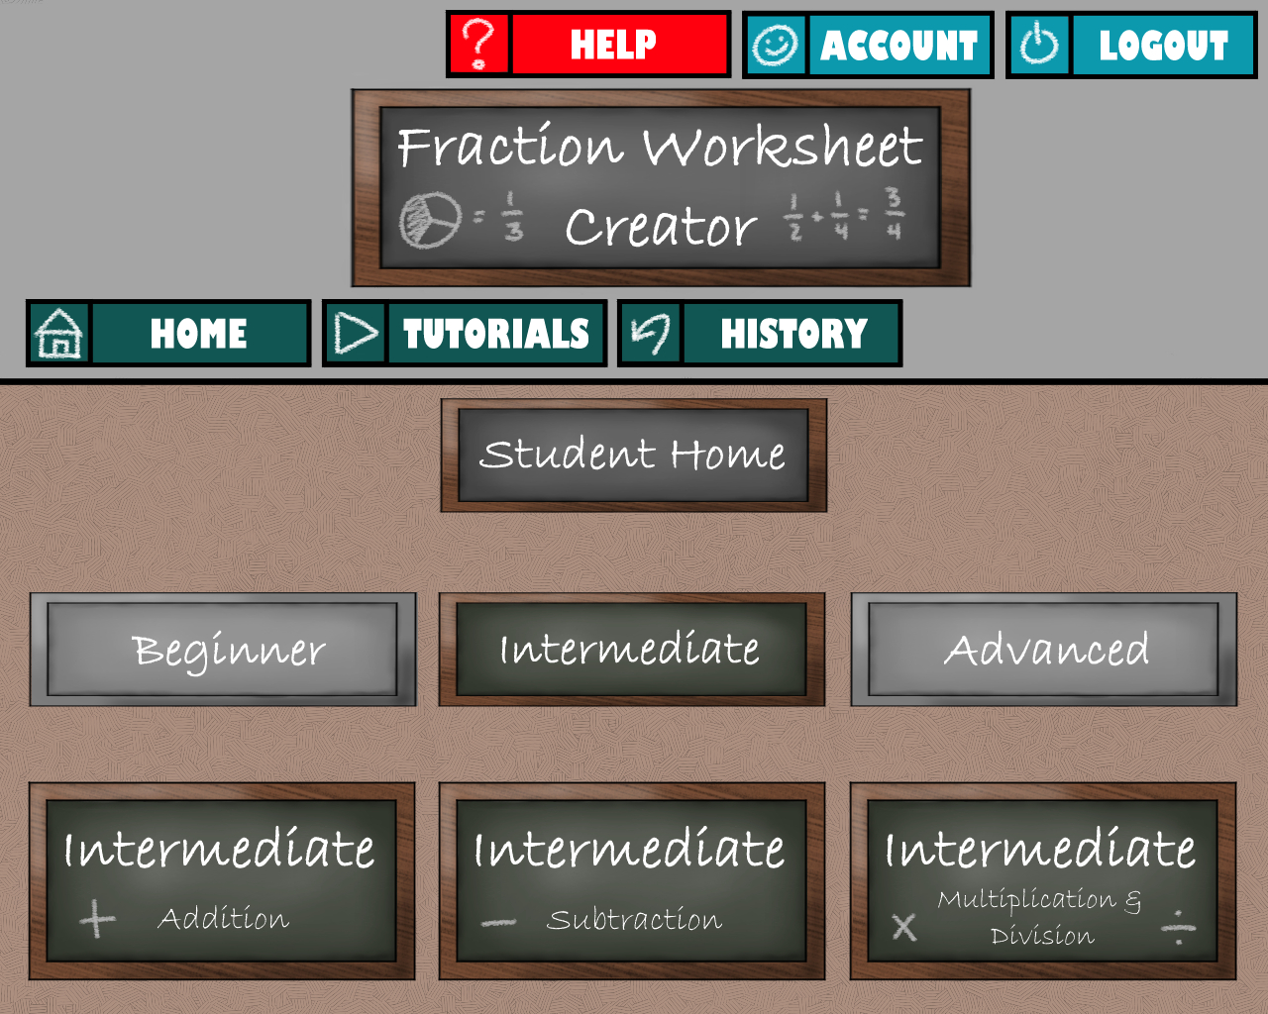

This is a sample of what the finished user interface may look like after including

graphical components.